Data Flow Diagrams

A Data Flow Diagram (DFD) is a visual representation of how data moves through the system - from raw housing sales records to the interactive Tableau dashboards consumed by end users.

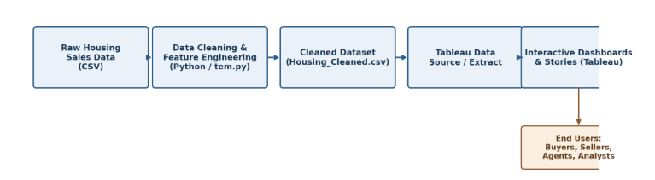

User Stories
